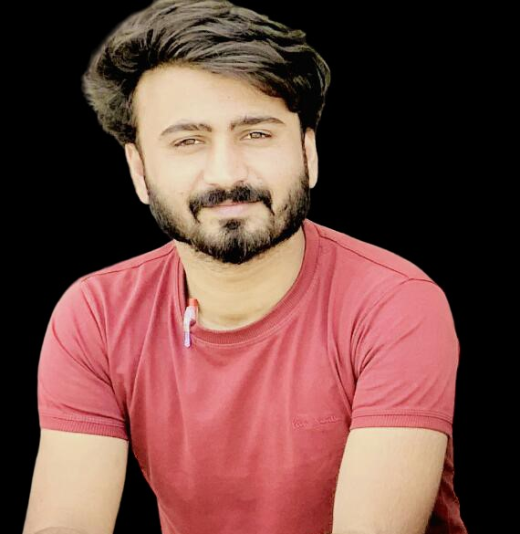 |  |  | Dear Sir/ Ma’am,  I am writing to express my enthusiastic interest in the Software Engineer position at your company, as seen on your company website. As a recent graduate with a strong foundation in software development and a passion for cutting-edge technology, I am excited about the opportunity to contribute to the ground-breaking work at your company.  My academic background and hands-on experience, including projects such as Face Recognition, C# applications, desktop and mobile apps, and Python programming/Django (Tumigo community and tumigo computer language) and you should have seen my git for my repos, have equipped me with a diverse skill set. Despite being a fresh graduate, I have demonstrated my ability to grasp complex concepts quickly and apply them effectively in various projects.  One of my notable achievements includes developing a robust face recognition system that showcased my proficiency in image processing and artificial intelligence. Additionally, my involvement in C# projects, desktop applications, and mobile apps has honed my programming skills and instilled in me a keen eye for detail and innovation.  While I may not have prior industry experience, my academic journey has equipped me with a solid foundation in software engineering principles and a proactive approach to learning and adapting to new challenges.  I am drawn to your company's commitment to pushing the boundaries of the organization. The prospect of contributing to projects that redefine the possibilities of technology and space travel aligns perfectly with my aspirations.  Enclosed with this letter is my resume, providing more details about my academic background and project experiences. I am eager to discuss how my skills and passion for software engineering can contribute to the dynamic environment at your company. Thank you for considering my application, and I look forward to the opportunity to further discuss my candidacy.  Sincerely,  Tariq Mehmood

TARIQ MEHMOOD
 | Multan, Pakistan
 | 03264848783
 | Johnbrrighte7427206@gmail.com
 | https://tariqmehmood1004.github.io/

